CST-221

Assessing Virtualization Software

Nate Ramey

Grand Canyon University: CST-221

Virtualization Software (VS) is software that allows the user to run apps that are constructed on a different operating system compared to the host computer. For instance, wanting to run a Windows based application on a Mac laptop or vice versa. VS can also import various software and see if it can run in different operating systems. This feature is offered on many different VS platforms to suit the user’s (or company’s) needs. Essentially a computer within a computer.

With my current employer, I work on automated test equipment (ATE) that utilizes many forms of software from different vendors. Software such as National Instruments and all the various drivers for all the individual resources, the individual software that is installed into every unit under test (UUT) along with the ATLAS program that is written by my employer that is ultimately execute normally on Windows OS based computer. However, we do have computers that are Windows NT, Windows 7 and recently we started to field Windows 10 to control an ATE. Along with this software, we utilize WINGS which is mainly a GUI for the testing software environment. SMART is a combination of .txt files that references the available resources that are configured to the ATE as well as the .txt files of how to run self-test. SMART also contains .txt files for all the TPS that are also configured to the ATE. All these different forms of software sometimes do not want to be compatible with each other when we compile everything together to see if we can test a UUT along with the different types of Windows platforms we offer. Especially with a newer UUT which requires newer resources and those drivers associated with those newer resources are different as well. A VS can help my company decide if the new UUT is even feasible just using the VS rather than having all necessary resources moved to a specific location, installing all resources, and then compile the code to see if it will work. A VS will help cut down on shipping costs, man hours, and time. While there are validation runs and FAA approved certificates to ensure all resources within the ATE and UUT are operating according to the FAA’s specifications. The initial VS test can help eliminate the unnecessary shipping costs, which can get expensive at times considering the average ATE is one ton. Even though mirroring the environment exactly for each test bench would be ideal since sometimes the theory doesn’t match up to having all resources and software physically connected. While majority of all VS is strictly software environment related compared to software controlling a physical resource, I think it is possible for the VS to mirror how a resource would behave to the code.

**Architecture of the VS environment for my application:**

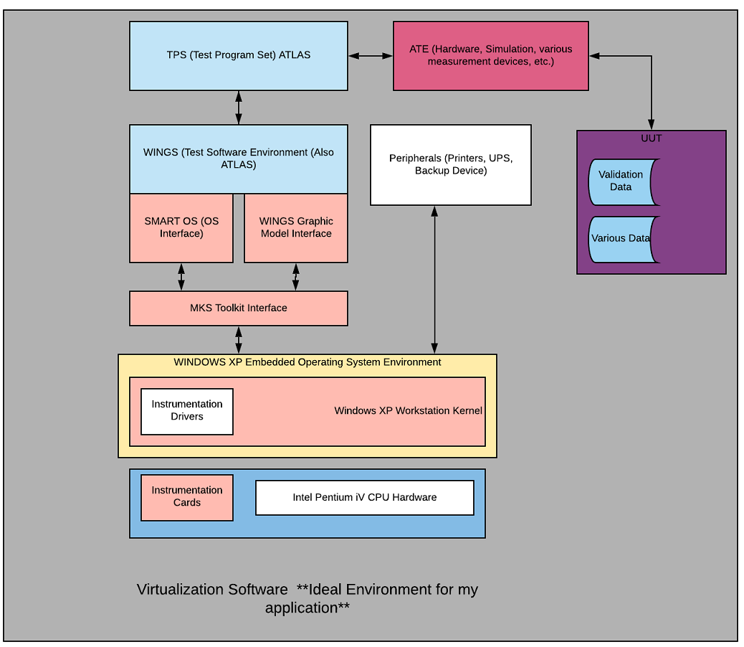

**Virtualization Software Solution 1:**

|  |  |  |
| --- | --- | --- |
| **Category** | **Score** | **Comment** |
| Company Name | NA | Dell EMC |
| Product Name | NA | VM ware |
| Version | 5 | ESXi 6.7 EP 07 A lot of bugs was fixed and patched implemented. |
| Release Date | 5 | 3/28/2019. Most up to date is always a plus. |
| Performance Metrics | 4 | Various Thresholds set for individual needs. Ideal for me since I can tailor it to my specific application. |
| Cost | 4 | While personal use is free, any commercial use is reasonability priced considering my company size. |
| Disaster Recovery Capabilities | 5 | Vmware does offer a disaster recovery plan. No additional charges needed. |
| Availability | 5 | VMware seems to be available 24/7 along with additional support for customer support. |
| Security | 4 | Seems they offer quite a bit of security from the cloud to their servers, but that’s it. Since majority of the software for my company is proprietary information, I need to be certain of a well-designed security system. |
| Infrastructure Scaling | 3 | VMware mentions the possibility of scaling but doesn’t really provide details. I would imagine this depends on the customer’s needs |
| Management Tools | 5 | VMware offers a variety of admin management tools. Which would be good for my application since I can limit the various information. |
| Report Generation | 5 | VMware offers report generation which is good since I can send the results to my immediate supervisor who might not understand the technical data. |
| Other: | NA |  |

**Notes:**

VMware seems to offer quite a lot of options for my application need. What has me concerned is how they didn’t explain the security framework very well. I understand its probably not a good idea to broadcast the detailed framework, but they should provide something better than the generic explanation they did. Which concerns me because as stated, the information on this software is proprietary.

**Virtualization Software Solution 2:**

|  |  |  |
| --- | --- | --- |
| **Category** | **Score** | **Comment** |
| Company Name | NA | Windows |
| Product Name | NA | Hyper-V |
| Version | 5 | Windows 10 Creators Update. |
| Release Date | 5 | Very recent update Jan 29, 2019 |
| Performance Metrics | 3 | Able to monitor performance metrics ON Hyper-V servers. Doesn’t specify which metrics are measured. |
| Cost | 3 | Varies on companies needs. More OS goals and processing ability requires more money. |
| Disaster Recovery Capabilities | 5 | Hyper-V creates copies of the virtual environment. |
| Availability | 5 | Hyper-V offers shared storage so maximize availability to their customers. |
| Security | 4 | Offers secured boot and shielded virtual machines aid in malware protection. |
| Infrastructure Scaling | 0 | Mostly for server applications. Doesn’t apply to my application. |
| Management Tools | 0 | Offers multiple ways of monitoring. However mostly server based. Doesn’t apply to my application. |
| Report Generation | 5 | Does offer report generation. |
| Other: | NA |  |

**Notes:** I don’t think Hyper-V applies to me and my application. It seems to gear more toward virtualization of various servers and how they would interact with each other. Perhaps there is options the users can choose, but it didn’t seem possible with what I found on the internet.

**Virtualization Software Solution 3:**

|  |  |  |
| --- | --- | --- |
| **Category** | **Score** | **Comment** |
| Company Name | NA | Oracle |
| Product Name | NA | Virtual Box |
| Version | NA | VirtualBox 6.1.4 Fixed regressions and added stability |
| Release Date | 5 | Feb 19, 2020 Version a few days old! |
| Performance Metrics | 2 | Need to install third party performance metric monitoring. This would take time to research which one works well for my application. |
| Cost | 5 | Free. Regardless of needs of customer (More Processing compared to another customer.) |
| Disaster Recovery Capabilities | 0 | VirtualBox doesn’t offer any DRP compared to other VS and their ability to create settings that updates their data. Once it’s lost, it would be rather difficult to recover. |
| Availability | 3 | Available 24/7. However, immediate customer support isn’t available. |
| Security | 1 | There seems to be security issues within VirtualBox. One time it took them 15 months to fix a bug they knew was present. Even one employee made a zero-day publication on GitHub. This won’t work for my application. |
| Infrastructure Scaling | 2 | VirtualBox doesn’t really state if the user can add to the scalability. |
| Management Tools | 3 | Virtual Box offers both remote and local management tools however, it doesn’t seem easy to set up. |
| Report Generation | 0 | Couldn’t find if there was a capability for this. |
| Other: |  |  |

**Notes:**

While VirtualBox is tailored more towards me application needs, I cannot look pass the security issues. Also, my application needs to have multiple users to see if when can run all the software. With that said, from my research, it seems difficult to set up remote users to the host computer.

**Virtualization Software Solution 4:**

|  |  |  |
| --- | --- | --- |
| **Category** | **Score** | **Comment** |
| Company Name | NA | IBM |
| Product Name | NA | RedHat Virtualization |
| Version | 5 | 4.3 |
| Release Date | 5 | May 15 2019 |
| Performance Metrics | 4 | Uses app called Metric Store. Seems that any type of metric can be generated from this to suite the user’s needs. |
| Cost | 4 | Charges per socket pair. Since I only need the workstation, I cannot discount taking the server out. So it’s $1,000 a year |
| Disaster Recovery Capabilities | 5 | Offers the customers a DRP that can tailor to them. Comes with subscription. |
| Availability | 5 | Offers 24/7 support if an issue arises. |
| Security | 5 | RedHat states they provide constant security updates to the virtualization platform. This is vital for my app. |
| Infrastructure Scaling | 5 | RedHat offers the option to increase using more sockets, but it will cost the customer more. |
| Management Tools | 5 | RedHat offers many forms of management tools. Since there is a lot of people will have access to my application, I can set the permissions. |
| Report Generation | 5 | RedHat has ways of generating reports. |
| Other: |  |  |

**Notes:**

Between VMware and RedHat it would be hard to choose since they both meet my needs for my application. Since my biggest concern is security, RedHat seems to pride themselves ensuring that all customers data/work is secured. I wish the price wasn’t so high which could be the deciding factor for my employer.

**Virtualization Software Solution 5:**

|  |  |  |
| --- | --- | --- |
| **Category** | **Score** | **Comment** |
| Company Name | NA | QEMU |
| Product Name | NA | QEMU |
| Version | 5 | 4.2.0 Which is a fairly recent version |
| Release Date | 5 | Dec 12, 2019 |
| Performance Metrics | 4 | QEMU offers ways to increase Windows based platforms. |
| Cost | 5 | Free |
| Disaster Recovery Capabilities | 0 | Doesn’t seem QEMU offers any type of DRP. This isn’t ideal for my application. |
| Availability | 3 | While QEMU offers 24/7 availability, they do not have any type of real time support. This is mainly because QEMU is free. |
| Security | 1 | QEMU isn’t secured. A lot of vulnerabilities for attackers. |
| Infrastructure Scaling | 4 | Scaling is up to the individual user. Initially the customer needs to set the parameters. |
| Management Tools | 3 | Tools are available; however, the user needs to install them. Since there is a variety, it would be hard to choose the right one. |
| Report Generation | NA | It isn’t possible to generate any reports for QEMU. |
| Other: |  |  |

**Notes:**

I wouldn’t consider this at all. From what I was able to discover, QEMU has a lot of issues. While the platform does seem like it can be built to meet the needs of my application, it would require a lot of work. I would also have to add more layers of security. Since I really don’t know how to do that, I wouldn’t sacrifice my application.

**My Top Choice:**

Considering the cost, I would have to go with RedHat. It seems that they have a complete VS for my application. Since all the software for my application can be quite large at times, it seems that RedHat’s performance can handle the workload. Another is their security. They offer multiple layers of security and the user can set up multi validation measure to ensure the data is safe. What also had me drawn to it is the flexibility of the VS. Since ATLAS isn’t relatively used a lot, I can implement it with little ease. I also like RedHat’s DRP. They even have redundancy plans for their own DRP. So, if the worst-case scenario ever were to happen, my application data will be safe.

**Topic 1:**

This is exactly the issue my company is facing. Since we must mesh both hardware and software for a functioning ATE, it can become tricky to do. It requires a lot of trial and error at times. If the engineer doesn’t know what they’re doing, they can risk damaging the hardware. Since most companies have a strict budget for research and development, buying another $80,000 PXI card will not go unnoticed. As stated earlier, If I could create within the VS a way to mimic how a hardware resource should act, the VS would save a lot of time. It might also help engineers decide which hardware resources to buy. For instance if I design a TPS to run using a specific set of hardware for a UUT, and my VS keeps “destroying” Programmable Gain Amplifiers, it would make sense for me to consider maybe using a different model of Programmable Gain Amplifier before I buy the one that fails in my VS simulator. Another issue is hardware constantly has drivers being updated. If any of these pieces of hardware are connected to any type of internet, the drivers will constantly try to either look for updates or update the resource without the user knowing. Which is frustrating to the engineers because one minute, their code is working and the next day the updated driver is causing errors. Another issue is validating the status of the hardware. For instance, unless the piece of hardware came right out of the box, then we can normally guarantee the resource will work. Whereas if we pick up a piece a random resource that is laying in stock or what have you, the current state of that piece of equipment isn’t know. While it might seem common sense that we should immediately suspect the resource as being at fault causing the software not to act accordingly. Unfortunately, this isn’t always the case.

**Topic 2:**

Since my application is Windows XP based, along with GPIB and VXI comm buses, sometimes other pieces of testing equipment that is configured to the ATE uses much older software and the ATE will time out. The While the ATE is sending commands to turn the oven on to a specific temperature, the status coming back is a SCPI based commands. These SCPI commands/status have a hard time on the GPIB bus since the status coming back from the other piece of equipment is so slow. Unfortunately, this example is the reverse of what the question is asking. Because it’s a slower code trying to be implemented to a faster code, I think this would take some time to translate it to a new faster code. I think another example is we have resources that are configured to run on LXI via ethernet. This form of communication is much faster compared to GPIB and regular VXI buses. During the initial testing of these new resources, we had to implement a delay in the comm bus because the data coming back from the LXI was so fast, it would miss the listen command for the computer to record the value. This would be something I would have to consider in my VS, but I don’t think I would be able to implement it. Mainly because I don’t think the software will know that the LXI ethernet resource will respond much quicker on the host computer. However, when these discoveries happen is when we have all the hardware and software functioning together. I highly doubt an issue like this would be discovered on an actual VS environment even if I tried to implement delays into the code. We sometimes run into this issue when a brand new UUT hits the market. While the TPS from us hasn’t changed, the customer will try to build their UUT to accommodate the ATE. This usually never is the case since the UUT sends/receives commands and statuses so quickly, the ATE will overwhelm its own communication bus.

References Used:

Mendelson, E. (June 28, 2019). *The Best Virtualization Software for 2020.* Retrieved https://www.pcmag.com/picks/the-best-virtualization-software

Flecha, P. (March 16, 2019). *Top 10 VMware Admin Tools.* Retrieved from https://blogs.vmware.com/virtualblocks/2019/03/16/top-10-vmware-admin-tools/

Lee, B. (July 18, 2018). *Hyper-V High Availability and Failover Clustering.* Retrieved from https://www.vembu.com/blog/hyper-v-high-availability-and-failover-clustering/

Honeyball, J. (April 6, 2011). *Is Hyper-V truly scalability Compared to the Competition.* Retrieved from https://www.cloudpro.co.uk/saas/it-application-management/611/hyper-v-truely-scalability-compared-competition

Balasubramaniam, P. (n.d.) *Top 10 VMware Performance Metrics That Every VMware Admin Must Monitor.* Retrieved from: https://www.eginnovations.com/blog/top-10-vmware-performance-metrics/

Yegulalp, S. (August 3, 2012). *VirtualBox VM recovery: Two Ways to Salvage Your Data.* Retrieved from https://searchvirtualdesktop.techtarget.com/tip/VirtualBox-VM-recovery-Two-ways-to-salvage-your-data

Cimpanu, C. (November 7, 2018). *VirtualBox Zero-Day Published By Disgruntled Researcher.*  Retrieved from https://www.zdnet.com/article/virtualbox-zero-day-published-by-disgruntled-researcher/

Andrews, J. (June 28, 2016). *VirtualBox Remote Management On Windows With HyperBox.*  Retrieved from: http://techgenix.com/remote-virtualbox-vms-hyperbox/

Huff, D. (October 20, 2016). *Red Hat Virtualization and Security.* Retrieved from https://www.redhat.com/en/blog/red-hat-virtualization-and-security

Ning, Y. (November 22, 2017). *Accelerating QEMU on Windows with HAXM.* Retrieved from https://www.qemu.org/2017/11/22/haxm-usage-windows/

Sharwood, S. (January 30, 2017). *Google Cloud Kicked QEMU to the Kerb to Harden KVM.* Retrieved from https://www.theregister.co.uk/2017/01/30/google_cloud_kicked_qemu_to_the_kerb_to_harden_kvm/